MS SQL SERVER
Standard Operating Procedures
(SOP)
Releasing Log space from Log files in SQL Server 2014

Submitted to



BY



CIS, Wipro Limited

Document Details

Project Name | Innogy SE
Account | CIS
IT Component/Application Title | Releasing Log space from Log files
Current Version | 1.2
List of Contributors | Pradipkumar Kansara, Kiran Bhalekar, Ayushi Gautam, Sivakumar Goud, Pramod Patil
Customer Contact Information

Version History
(All revisions made to this document must be listed in chronological order. All revisions must be approved. Review and Approval can be done by an internal source or by the customer)
Version | Date of Revision | Description | Author | Reviewed By | Approved By
1.0 | 05-12-2017 | Initial Draft | Ayushi Gautam | Pradipkumar Kansara | Santosh Badiger
1.1 | 05-12-2017 | Document Completed | Kiran Bhalekar | Pradipkumar Kansara | Santosh Badiger
1.2 | 06-11-2018 | Updated the content | Pramod Patil | Pradipkumar Kansara | Santosh Badiger

Document Distribution List
Sr.No | Name and Company | Purpose
1 | RWEIT-SQLDBA | Document is useful for managing logs in SQL server 2014.

TABLE OF CONTENT
1. Purpose 1
2. Scope 1
3. Releasing Log space from log files 1
4. Best Practice 8
5. Reference 8

Purpose
This document is prepared for the release and management of log space from log files in SQL Server Database Administration Services.

Scope
This document is prepared for SQL Wipro sustenance team and provides the concepts, management of log space from log files for the administration of the SQL Server database.

Release log space from log files
If you know that a transaction log file contains unused space that you will not be needing, you can reclaim the excess space by reducing the size of the transaction log. This process is known as shrinking the log file.
Shrinking can occur only while the database is online and while at least one virtual log file is free. In some cases, shrinking the log may not be possible until after the next log truncation.

Steps:

- To shrink the log in SSMS, right click the database, choose Tasks, Shrink, Files:

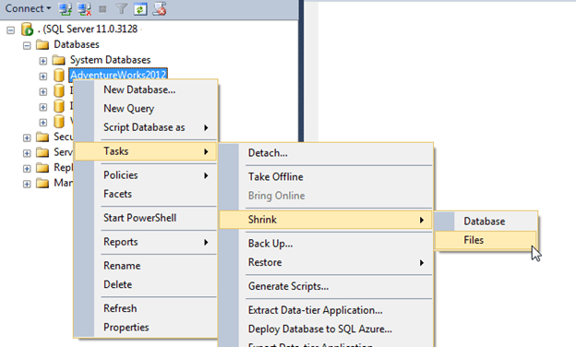
- On the Shrink File window, change the File Type to Log. You can also choose to either release unused space, reorganize pages before releasing unused space, or empty file by migrating the data to other files in the same filegroup:

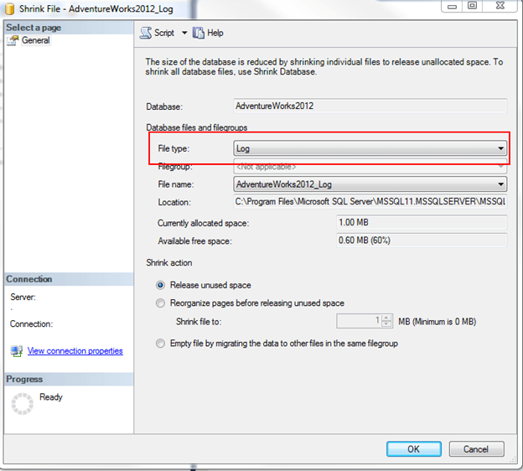

- It is always recommended to take log backup before shrinking logs. Take a log backup before shrinking logs and then shirk the logs, take another log backup just after you shrunk the logs.
- Also it is preferred to script out the log shrink and then only go for it like below screenshot:

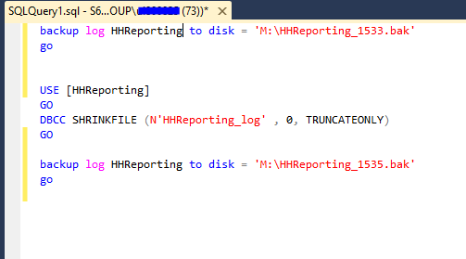

Best Practice
- For normal day-to-day operations, we would recommend starting at 25% of the data file size. So if data file is 20GB, make the log 5GB. Keep an eye on the log to see if it continuously grows beyond 5GB. Every time log grows, we add more VLF’s which can cause performance problems. 25% is the recommended starting point for normal operations, however, if we’re doing index rebuilds every night or if using high availability options such as replication or mirroring, we’ll need enough log space to hold onto the extra transactions that may occur.

Reference

- https://technet.microsoft.com/en-us/library/ms178037(v=sql.105).aspx

